GTEC 22061
SYSTEM NETWORK AND LABROTARY

Day2 LAB - ETHERNET SWITCHING

CT/2021/039
B.R.S.Sasikala

STEP 01 - Connecting Two PCs to a Switch
- Use appropriate Ethernet cables to connect two PCs to a switch.
- Establishes a physical connection between the devices to facilitate network communication.

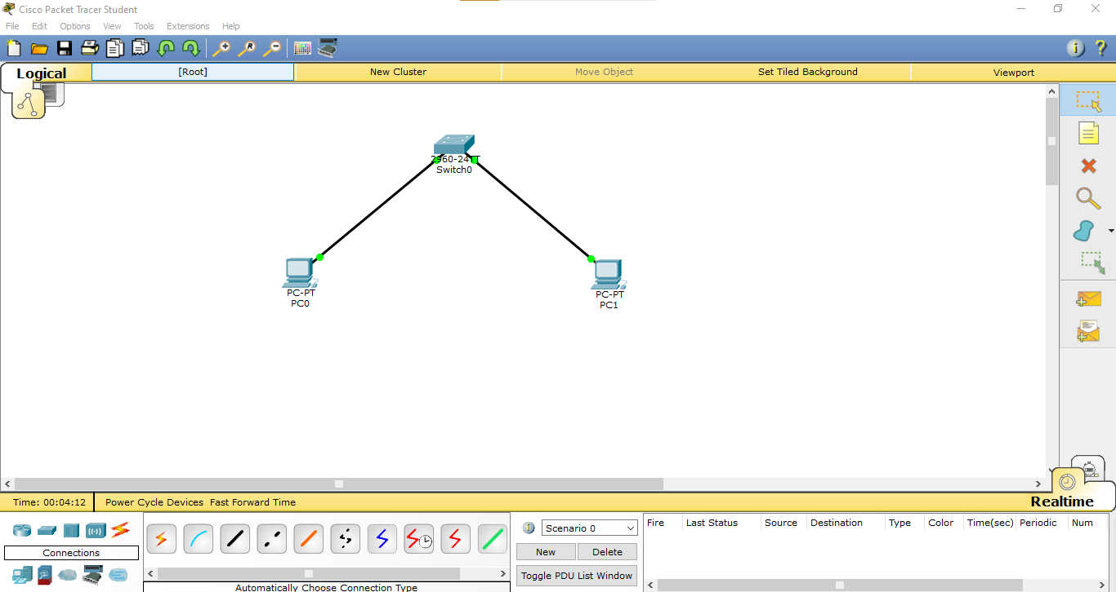

STEP 02 - Configuring Static IP Addresses
- Navigate to the PC’s Config tab, select “Static” and assign IP addresses (192.168.10.2, 192.168.10.3) and a subnet mask.
- Enables direct communication between the PCs by assigning fixed IP addresses.

PC1
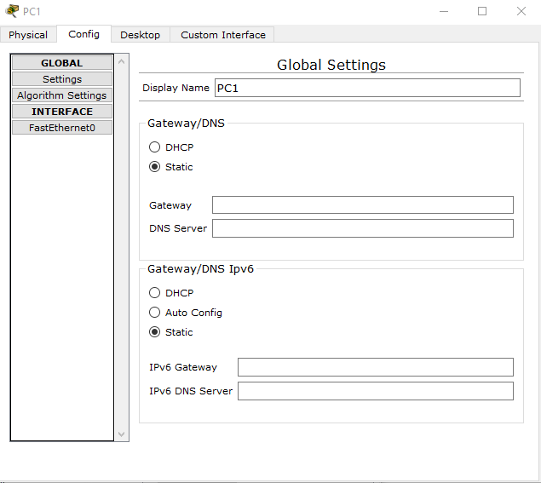

PC0
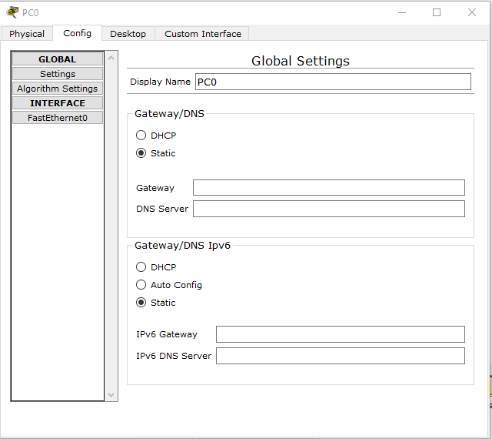

STEP 03 - Checking the MAC Address
- Identifies the unique hardware address for each network interface

PC0
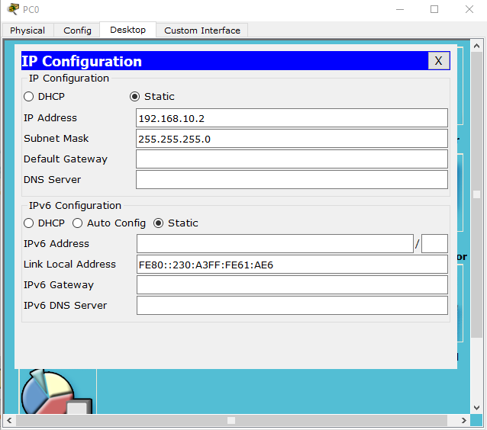

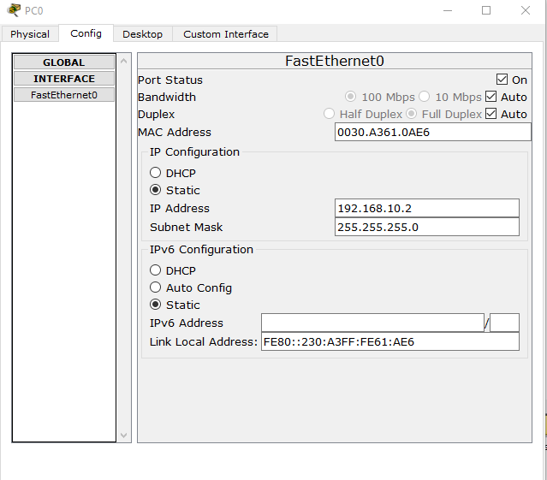

IP Address – 192.168.10.2
MAC Address – 0030.A361.0AE6

PC1
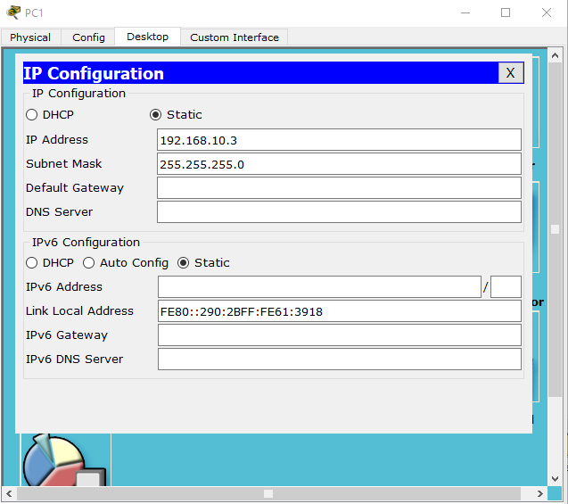

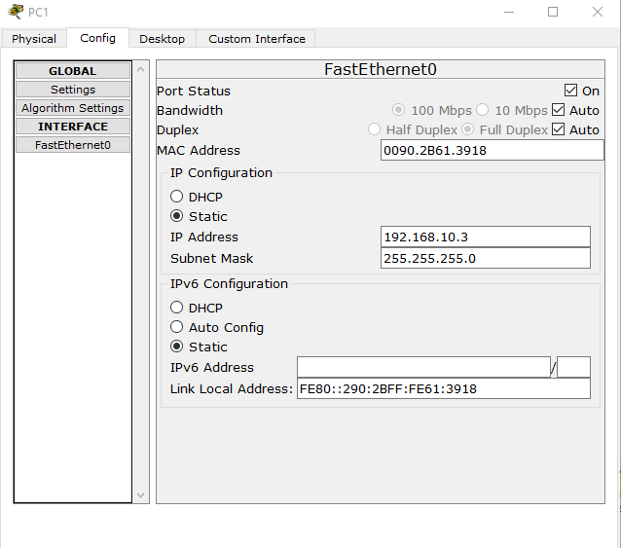
IP Address – 192.168.10.3
MAC Address is 0090.2B61.3918

STEP 04 - Confirming IP Configuration
- Verifies that the correct IP address has been assigned.
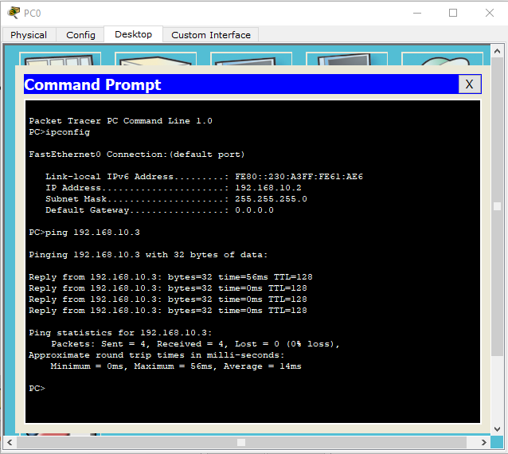

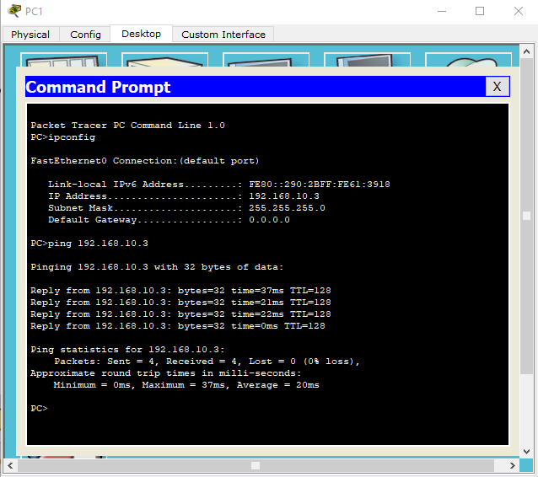

STEP 05 - Changing to DHCP Configuration
- Allows the PC to obtain an IP address dynamically from a DHCP server.

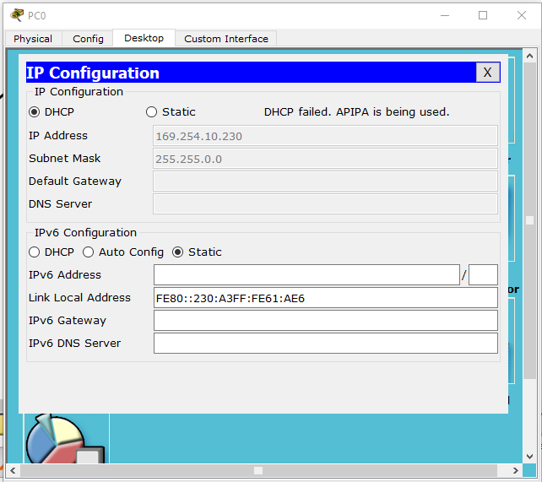
IP Address – 169.254.10.230

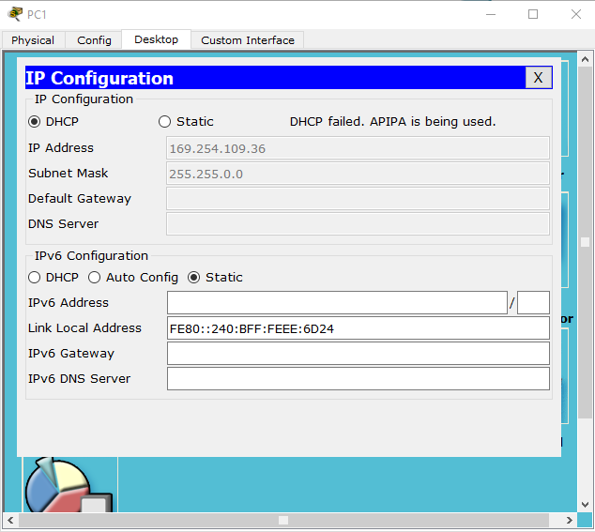
IP Address – 169.254.109.36

STEP 06 - Adding and Configuring a DHCP Server
- Connect a server to the network and enable the DHCP service.
- Allows automatic assignment of IP addresses to devices in the network.

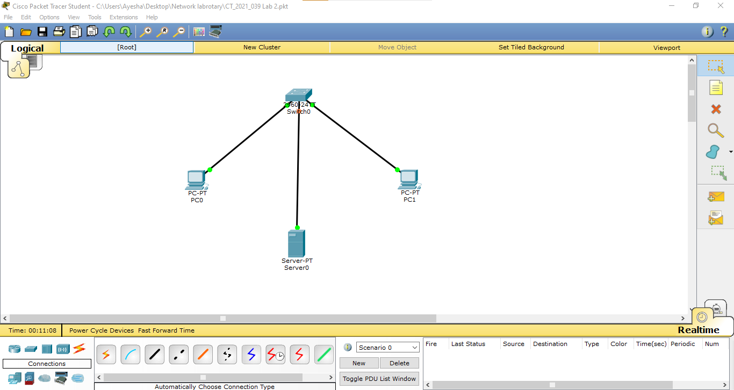

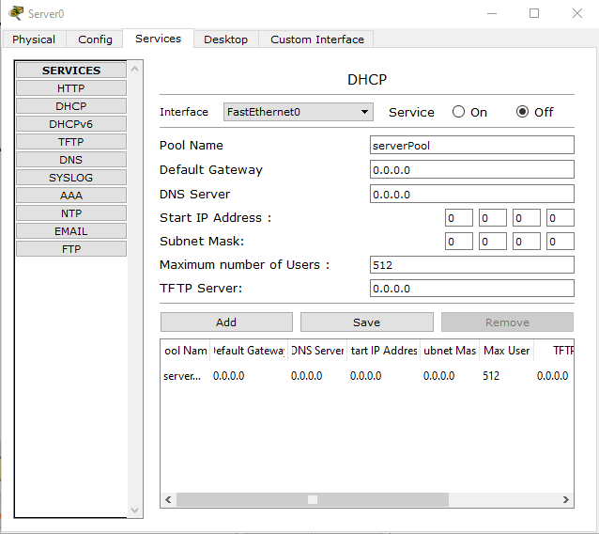

STEP 07 - Configuring DHCP Settings
- In the DHCP configuration window, set pool name, starting IP, subnet mask, and user limit.
- Defines the range of available IPs and enables dynamic addressing.

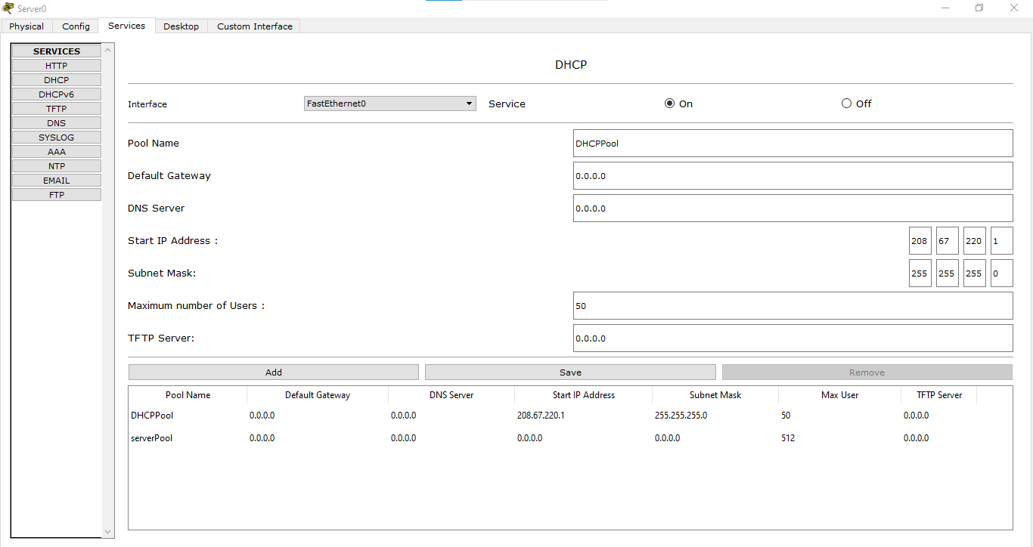

STEP 08 – Configuring the server’s FastEthernet Interface
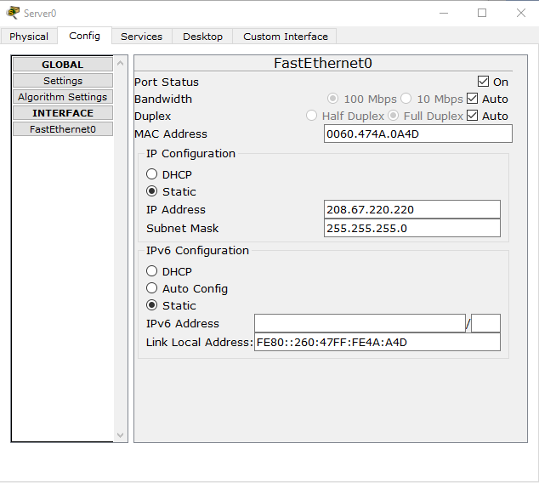
- Ensures the DHCP server has a fixed address for network stability.

STEP 09 - Verifying DHCP Assigned IPs
- Check if PCs obtain IPs dynamically from the configured DHCP range.
- Confirms that the DHCP server is functioning correctly.

PC0
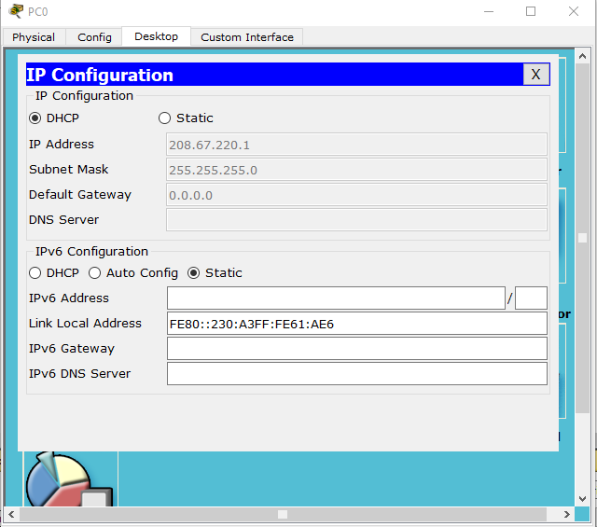
IP Address – 208.67.220.1

PC1
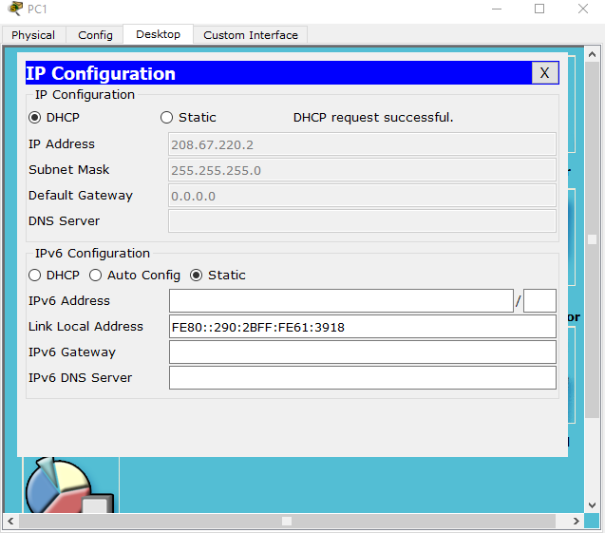

IP Address – 208.67.220.2
Both IP Addresses of PCs are from DHCP server IP Range.

STEP 10 - Configuring a DNS Server

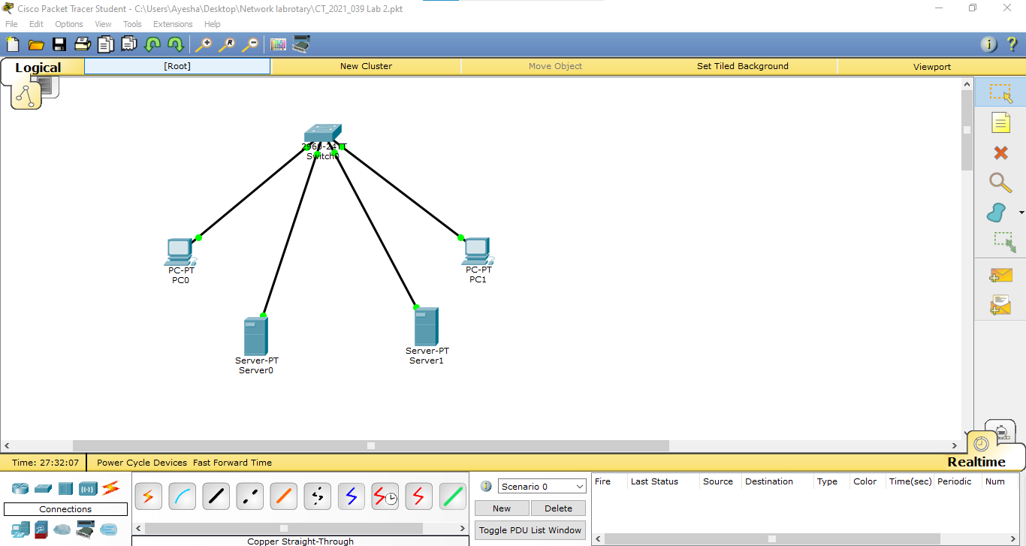
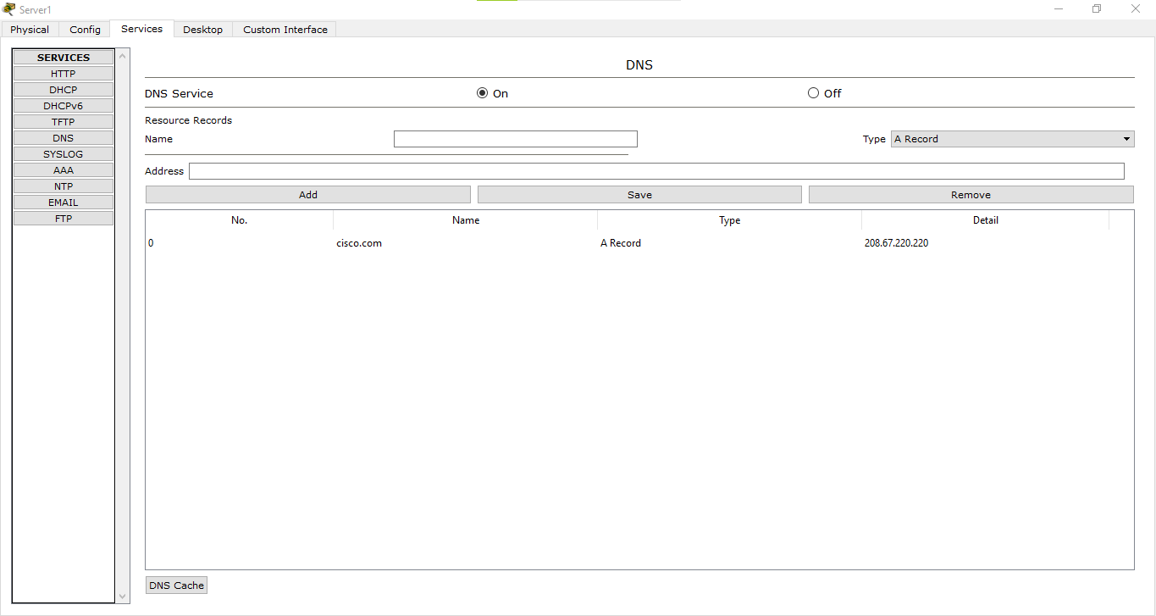

- Provides mapping between domain names and IP addresses.

STEP 11 - Adding DNS to DHCP Settings
- Ensures that DHCP clients receive the correct DNS information.

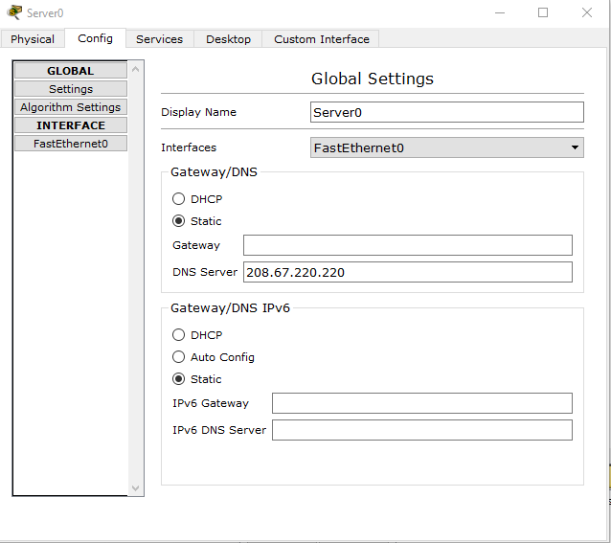

STEP 12 - Refreshing IP Configuration
- Refreshes the IP configuration to apply DHCP settings.
PC0
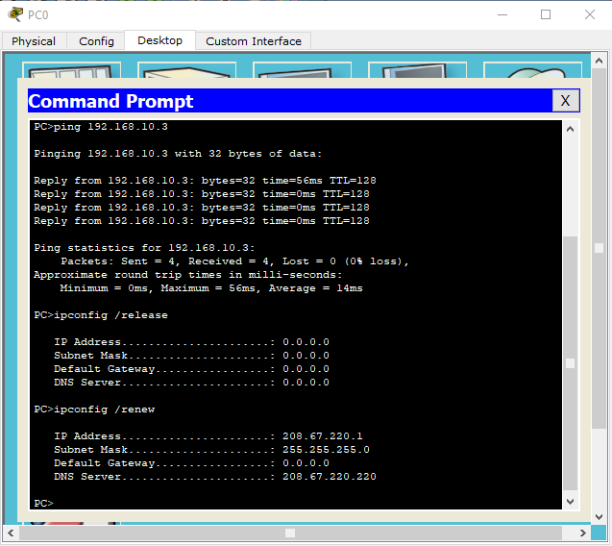

PC1
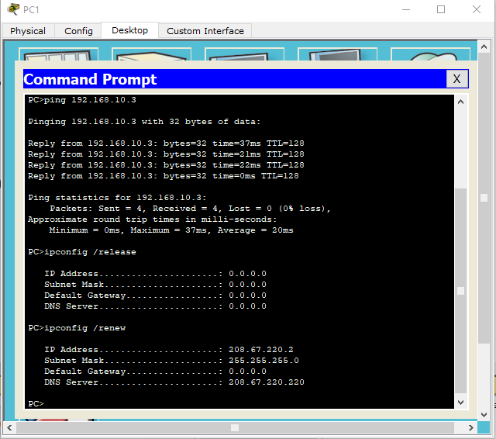
STEP 13 - Testing Connectivity with Ping
- Use the ping command to check communication between devices.
- Verifies network connectivity and packet transmission.

PC0
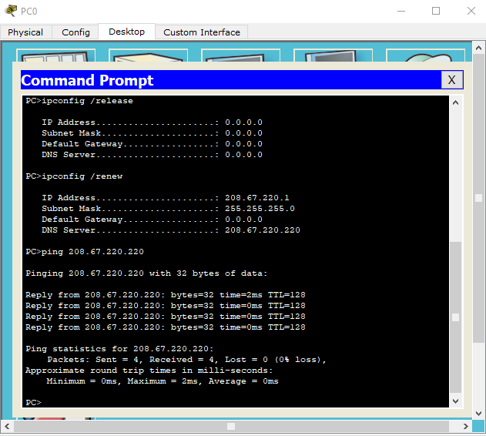

PC1
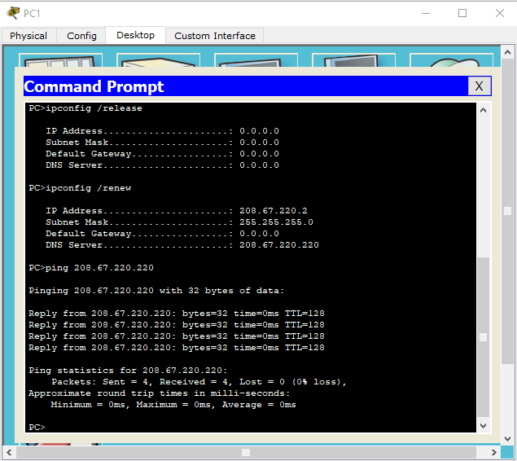

STEP 14 - Expanding the Network with Additional PCs
- Add more PCs to the switch and configure them similarly.
- Expands the network while maintaining connectivity.
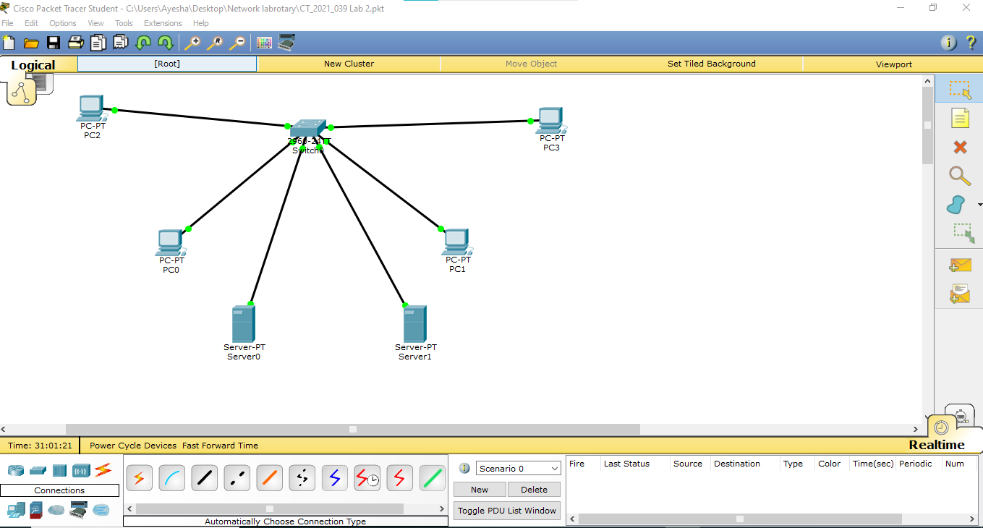
PC2
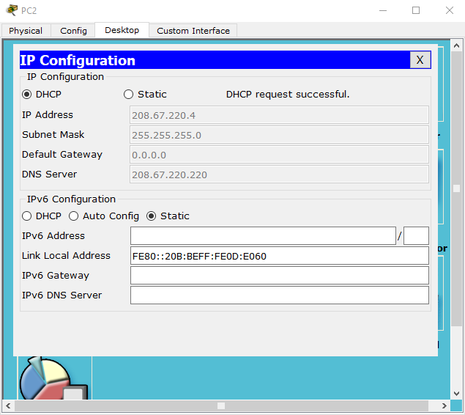
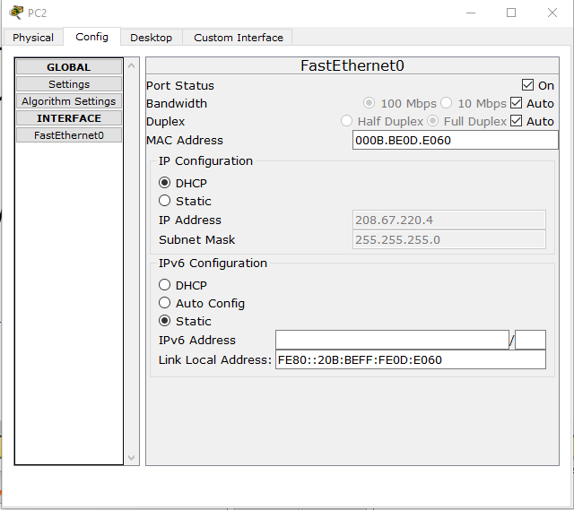

IP Address - 208.67.220.4
MAC Address – 000B.BE0D.E060

PC3
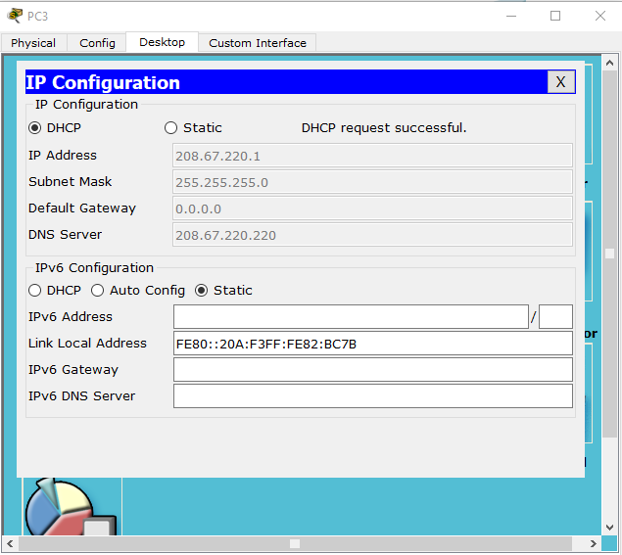
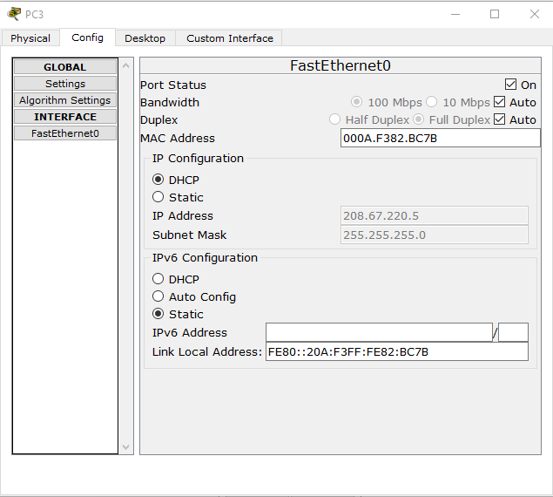
IP Address – 208.67.220.1
MAC Address – 000A.F382.BC7B

STEP 15 - Configuring the Switch via CLI
- Enhances switch security and management.

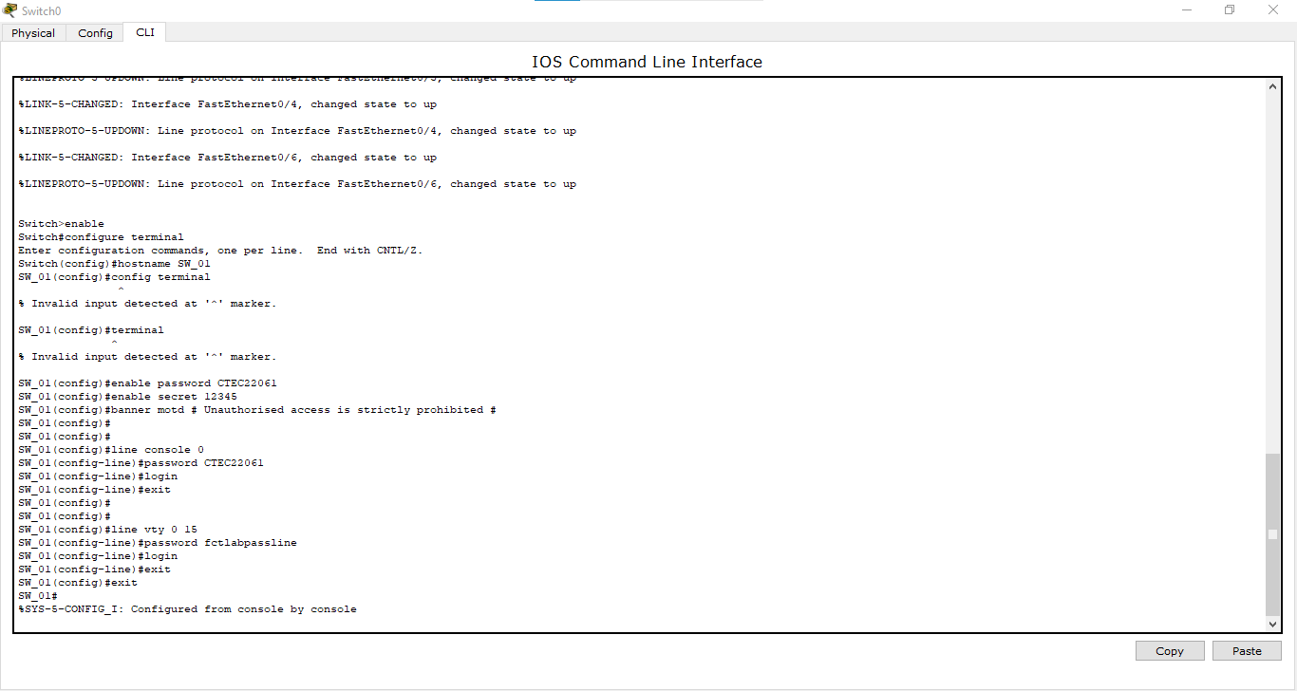

- Password: Stores the password in plain text, making it less secure.
- Secret: Stores the password in an encrypted format, making it more secure.
Best Practice - Always use enable secret instead of enable password for better security.

- Line Console - Used for local access via a physical console cable.
- Line VTY - Used for remote access via Telnet or SSH.
Console access is for on-site configuration, while VTY access allows remote management of the switch.

STEP 16 - Saving the Switch Configuration
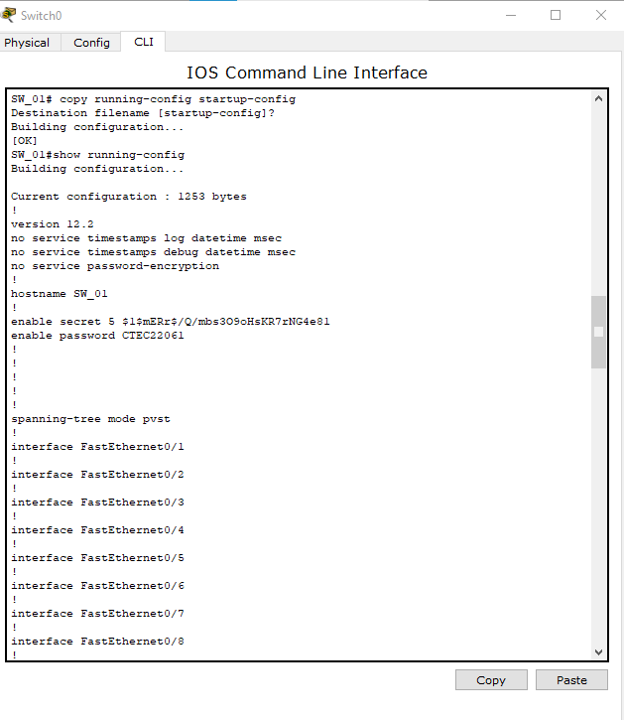
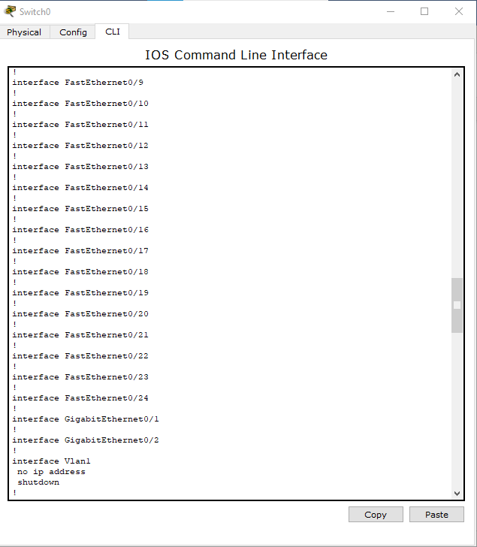
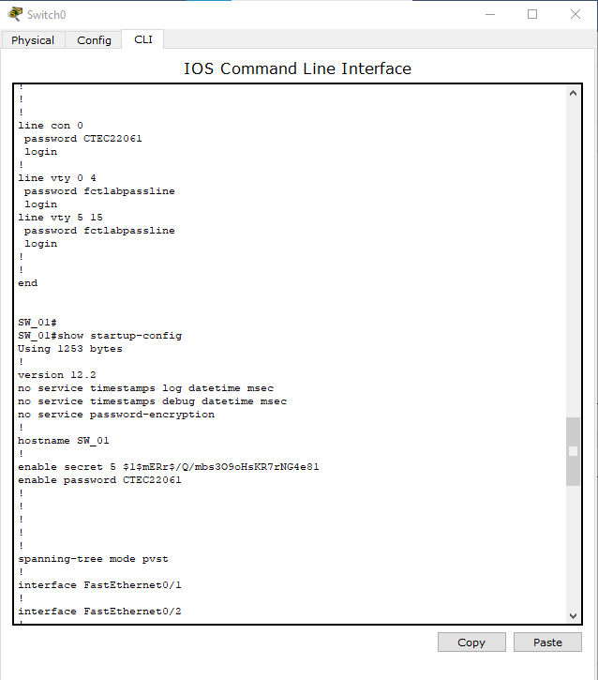

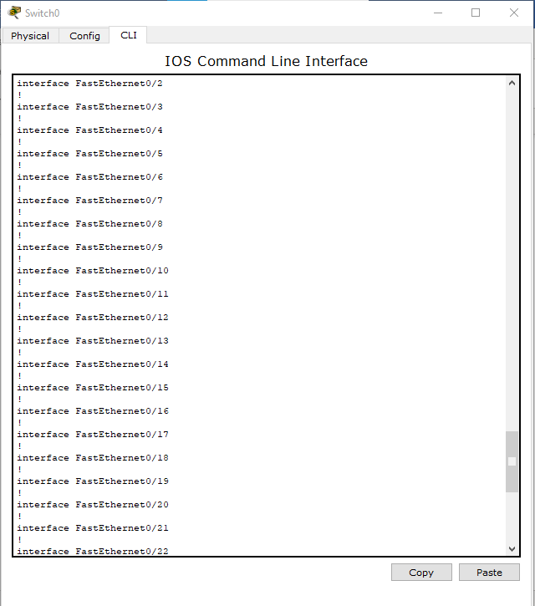
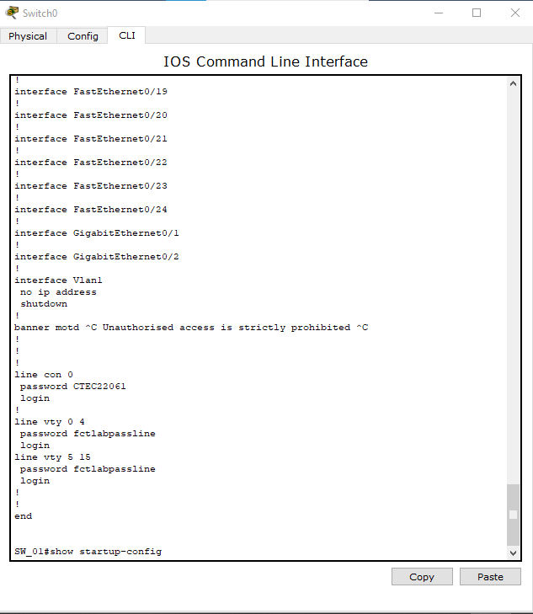

STEP 17 - Viewing and Managing the MAC Address Table
- Displays and controls MAC address learning and forwarding.

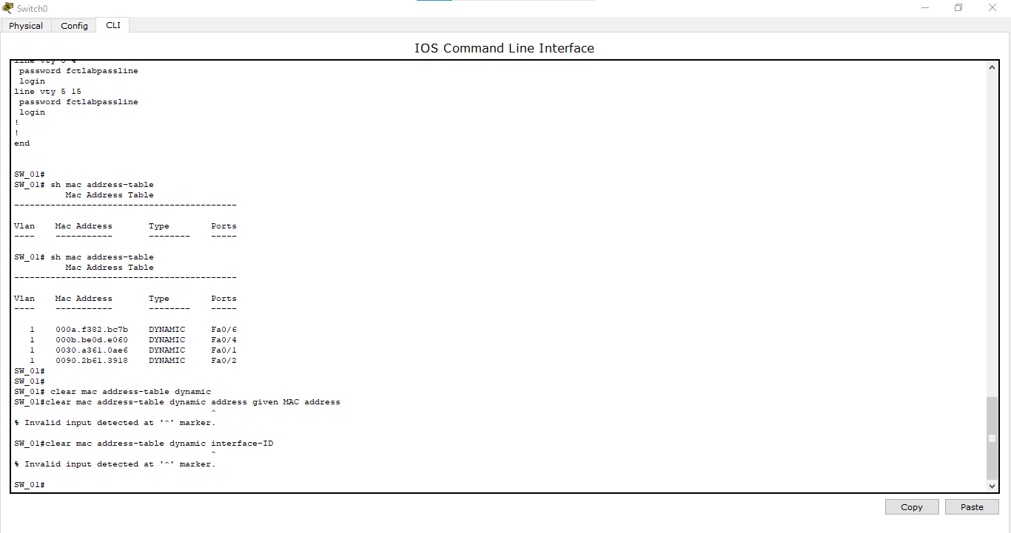
MAC Address table
MAC address table (also known as the CAM table) in a switch contains the following key data:
- VLAN (Virtual Local Area Network) – Identifies the VLAN to which the MAC address belongs.
- MAC Address – The unique hardware address of a device connected to the switch.
- Type – Indicates whether the MAC address is dynamic (learned by the switch) or static (manually configured).
- Port (Interface) – Specifies the switch port where the MAC address was learned.
This table allows the switch to forward frames efficiently by mapping MAC addresses to specific switch ports, ensuring data is sent to the correct destination without unnecessary broadcasting.
arp -a
The arp -a command displays the Address Resolution Protocol (ARP) table, which maps IP addresses to MAC addresses on a computer or router.
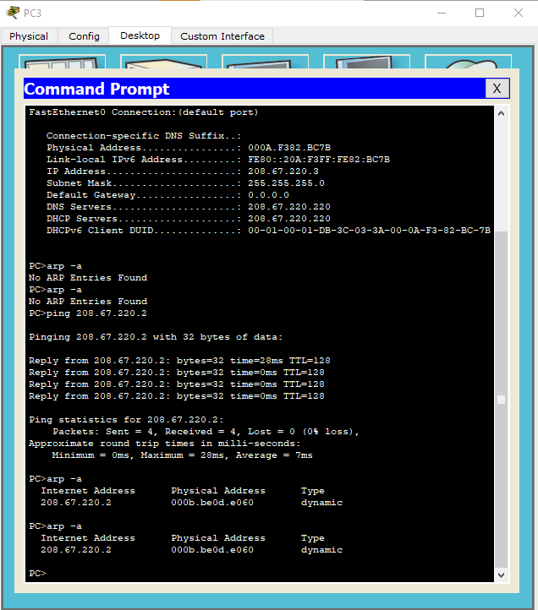
STEP 18 - Using Simulation Mode
- Add a simple PDU, enable ICMP filtering, and analyze packet movement.
- Helps visualize and troubleshoot packet transmission.
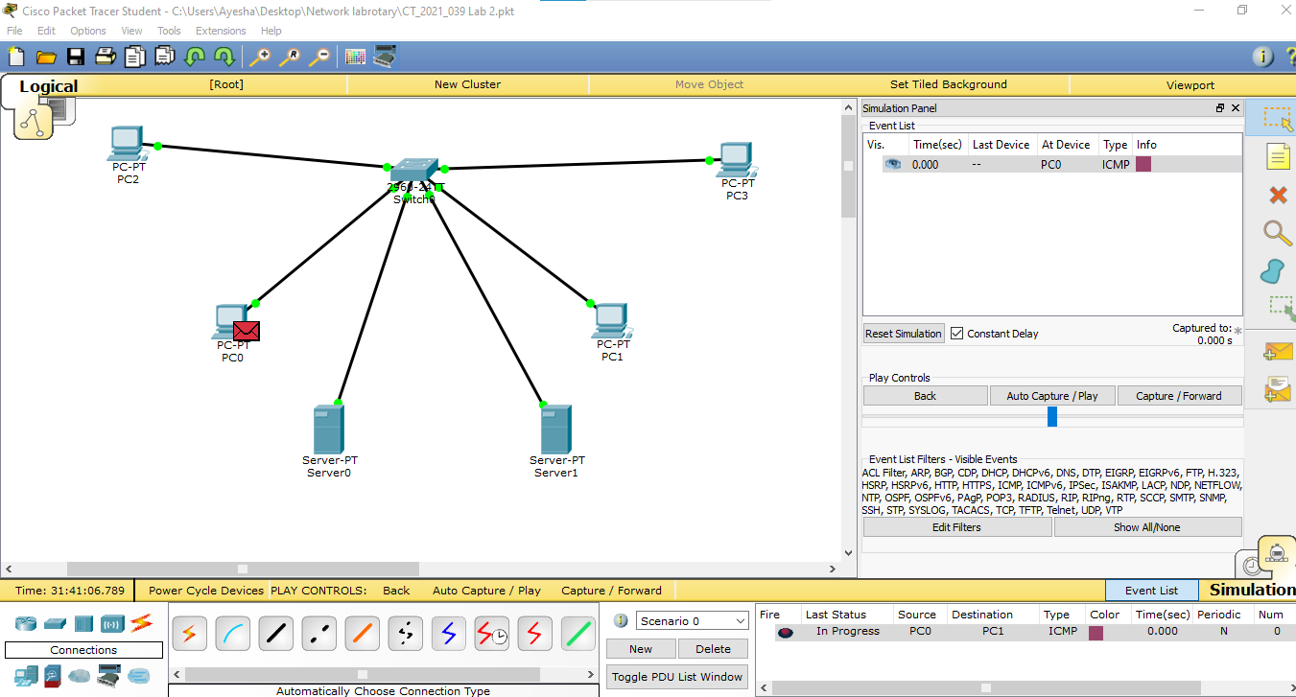

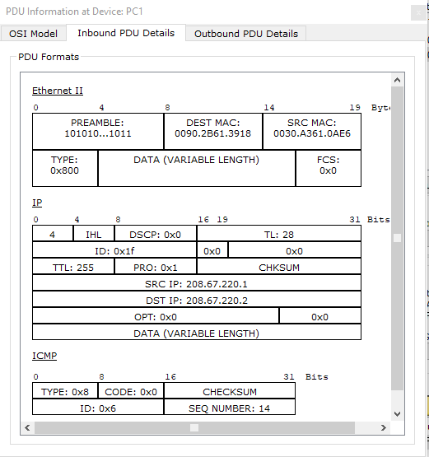
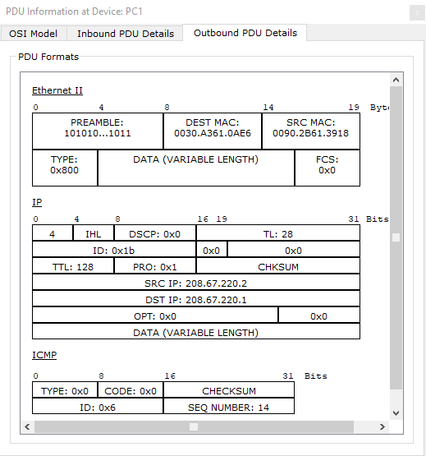

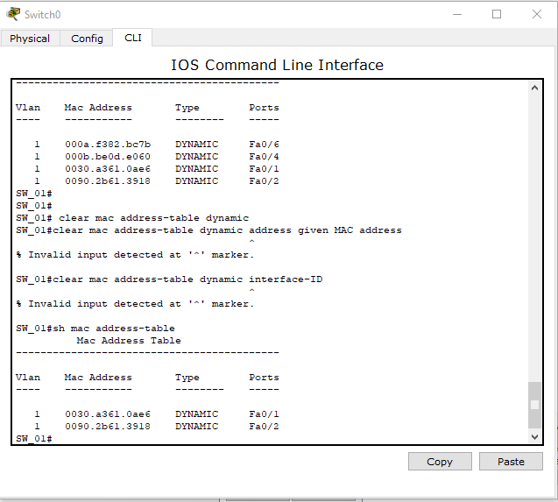

In this table two MAC addresses are learned on Fa0/2 and Fa0/5.it means devices are actively communicating these ports.
STEP 19 - Connecting a Wireless Router
- Add a wireless router, configure SSID “HomeNetwork,” and enable DHCP.
- Provides wireless connectivity within the network

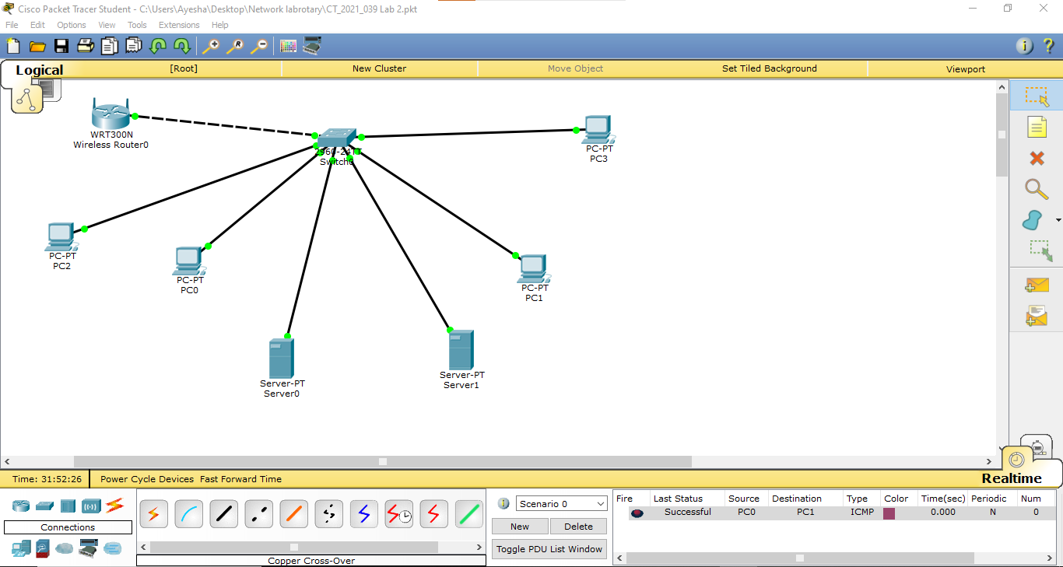

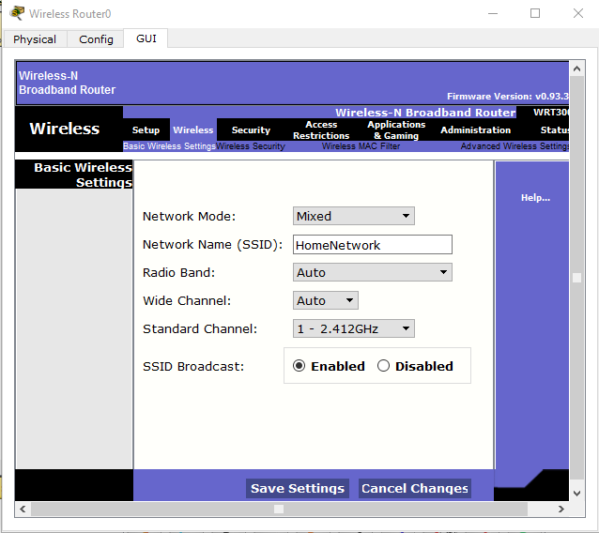
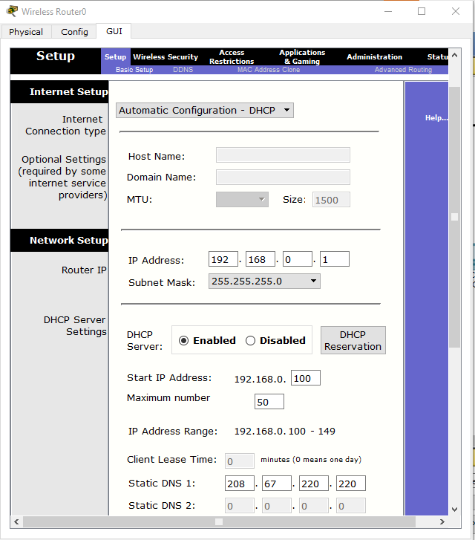

STEP 20 - Configuring a Laptop for Wireless Connection
- Power off the laptop, remove the Ethernet module, install a Wireless WPC300N module, and power it back on. Connect to the wireless network “HomeNetwork” from the PC Wireless settings.
- Enables the laptop to communicate wirelessly within the network.
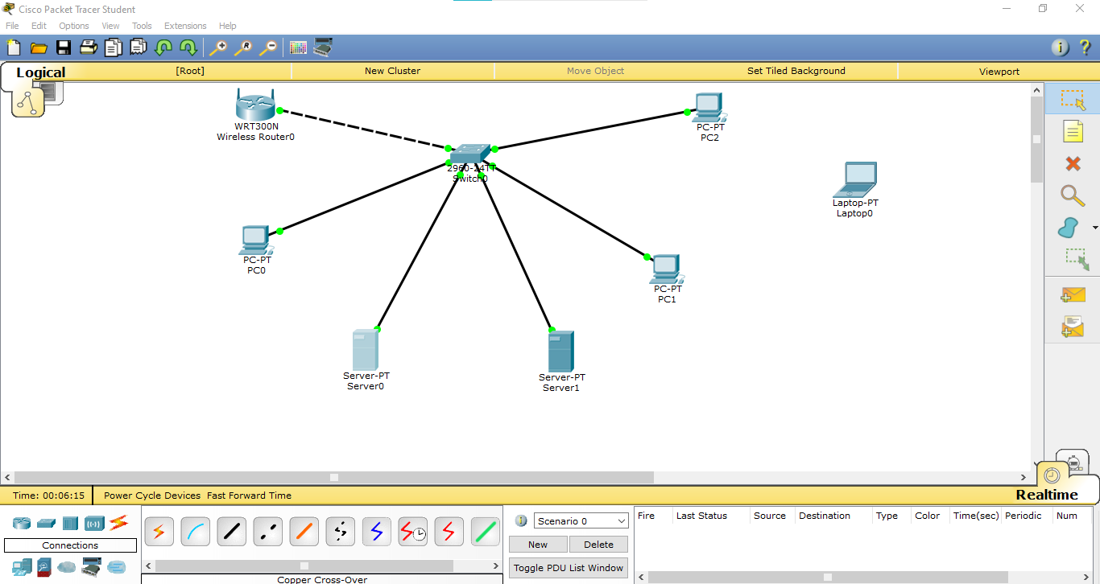

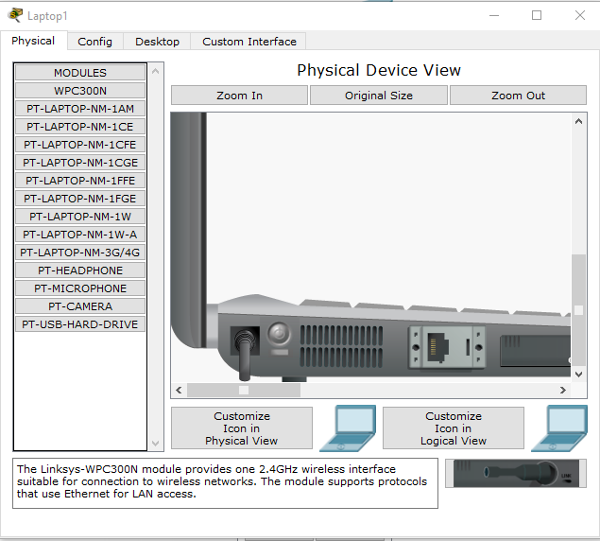

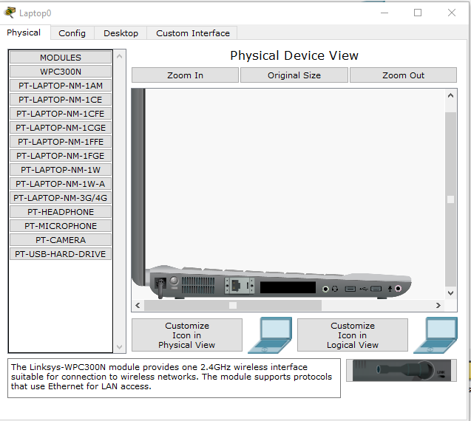

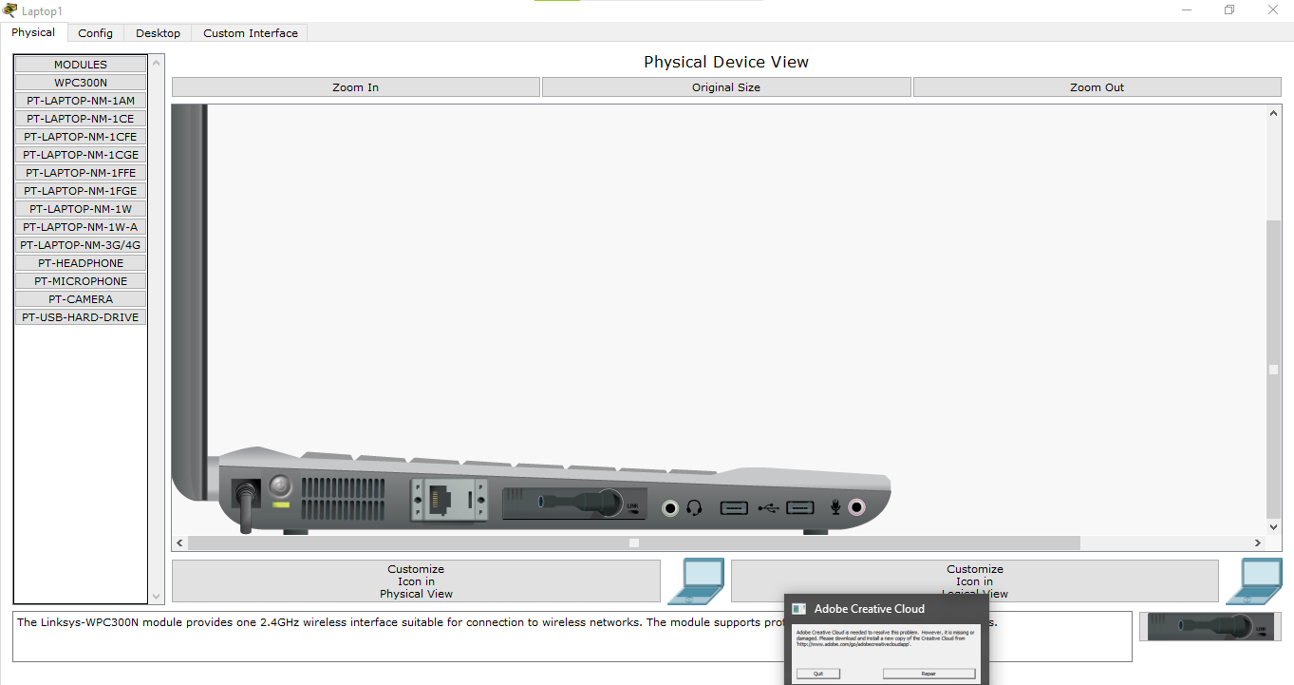

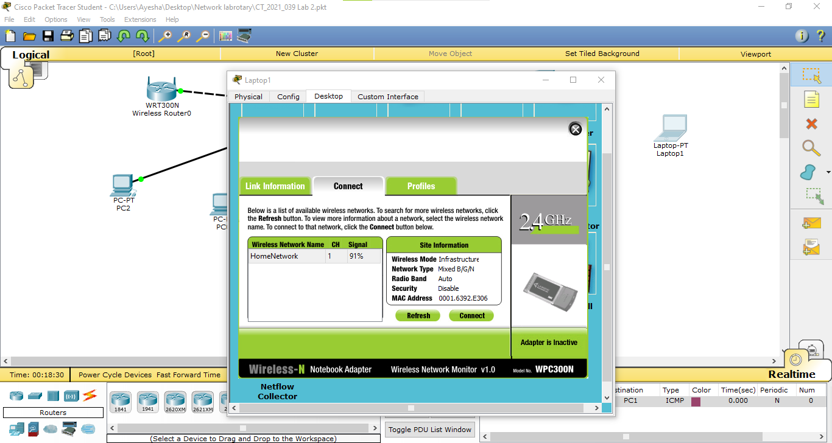

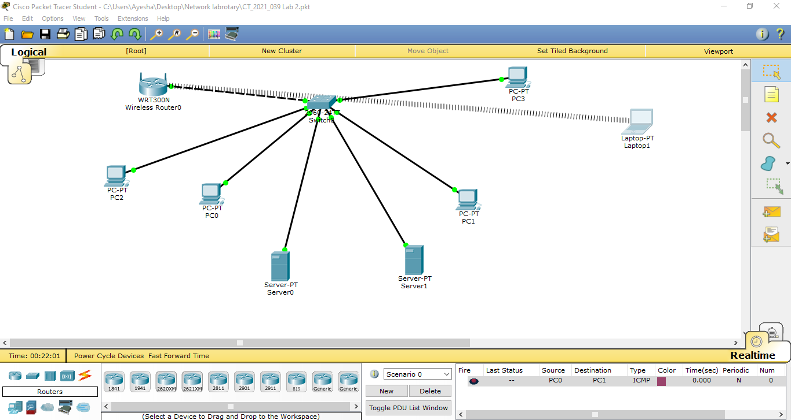

STEP 21 – Testing Wireless Network Connectivity
- Use ipconfig to check the assigned IP address and ping to test communication between the laptop and a PC connected to the switch.
- Verifies that the laptop has successfully connected to the network and can communicate with wired devices.

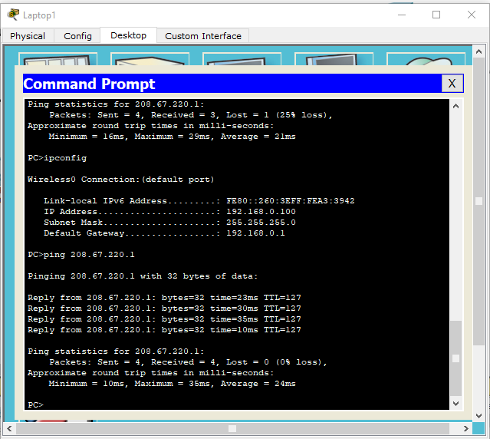

- Here laptop ping with 208.67.220.1,using PC3’s IP address the connection between the laptop and the PC3 becomes successful.
- Laptop sent 4 packets and PCs received all the packet successfully.
- The same method can be applied to other PCs to establish a successful connection with the laptop.

